**lab Exercise 6.2**

**Creating a New Jenkins Job to Checkout Source Code**

**Objective:** To set up a Jenkins job to manage source code, specifically by configuring the Source Code Management section to check out code from a Git repository

**Tools required:** Jenkins

**Prerequisites:** Jenkins must be operational.

Steps to be followed:

1. Log in and create a Jenkins job
2. Configure source code management

**Step 1: Log in and create a Jenkins job**

1. Navigate to **localhost:8080** in your web browser, enter your credentials, and click on **Sign In**

**Note**: The credentials for accessing Jenkins in the lab are Username: **admin** and Password: **admin**.

1. Create a new Jenkins job by clicking on **New Item**

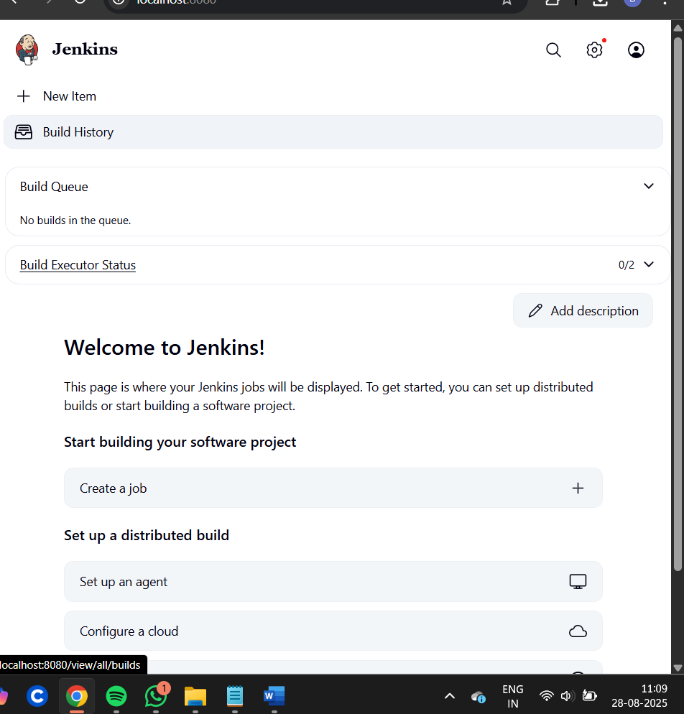

1. Provide custom job name inside the field **Enter an item name,** select the **Freestyle project** option,and click on the **OK** button to save the job

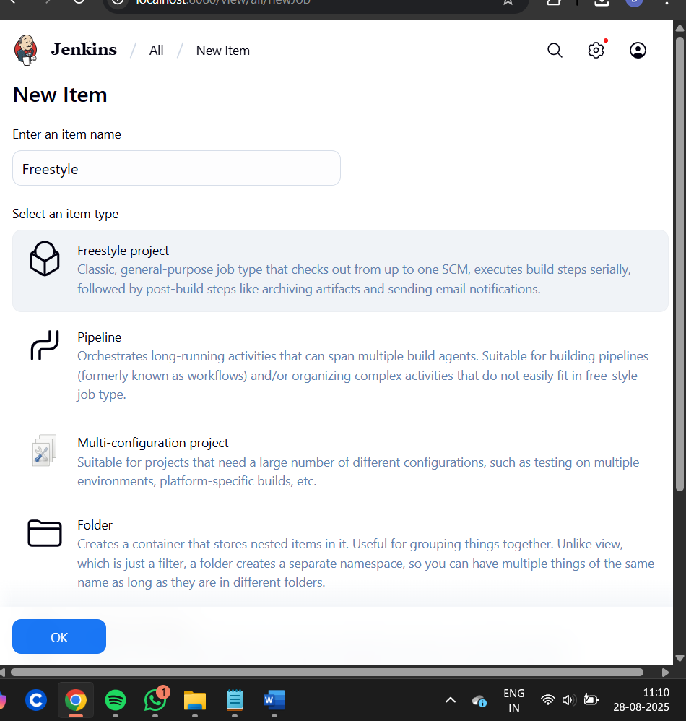

**Step 2: Configure source code management**

1. Access the newly created job's configuration screen by clicking on **Configure**

1. Navigate to the **Source Code Management** tab, provide Git repository configuration inside the **Repository URL** field, and click on the **Save** button

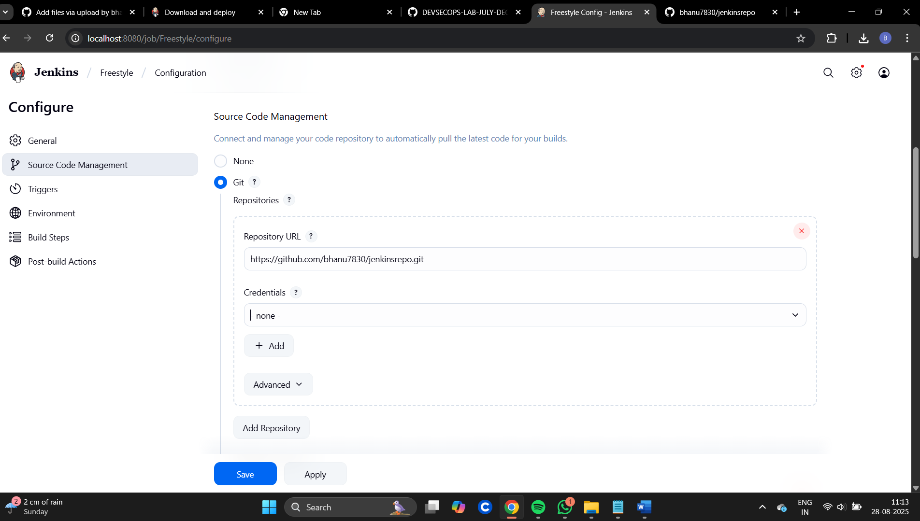

1. Then, click on the **Build Now** option to schedule a build

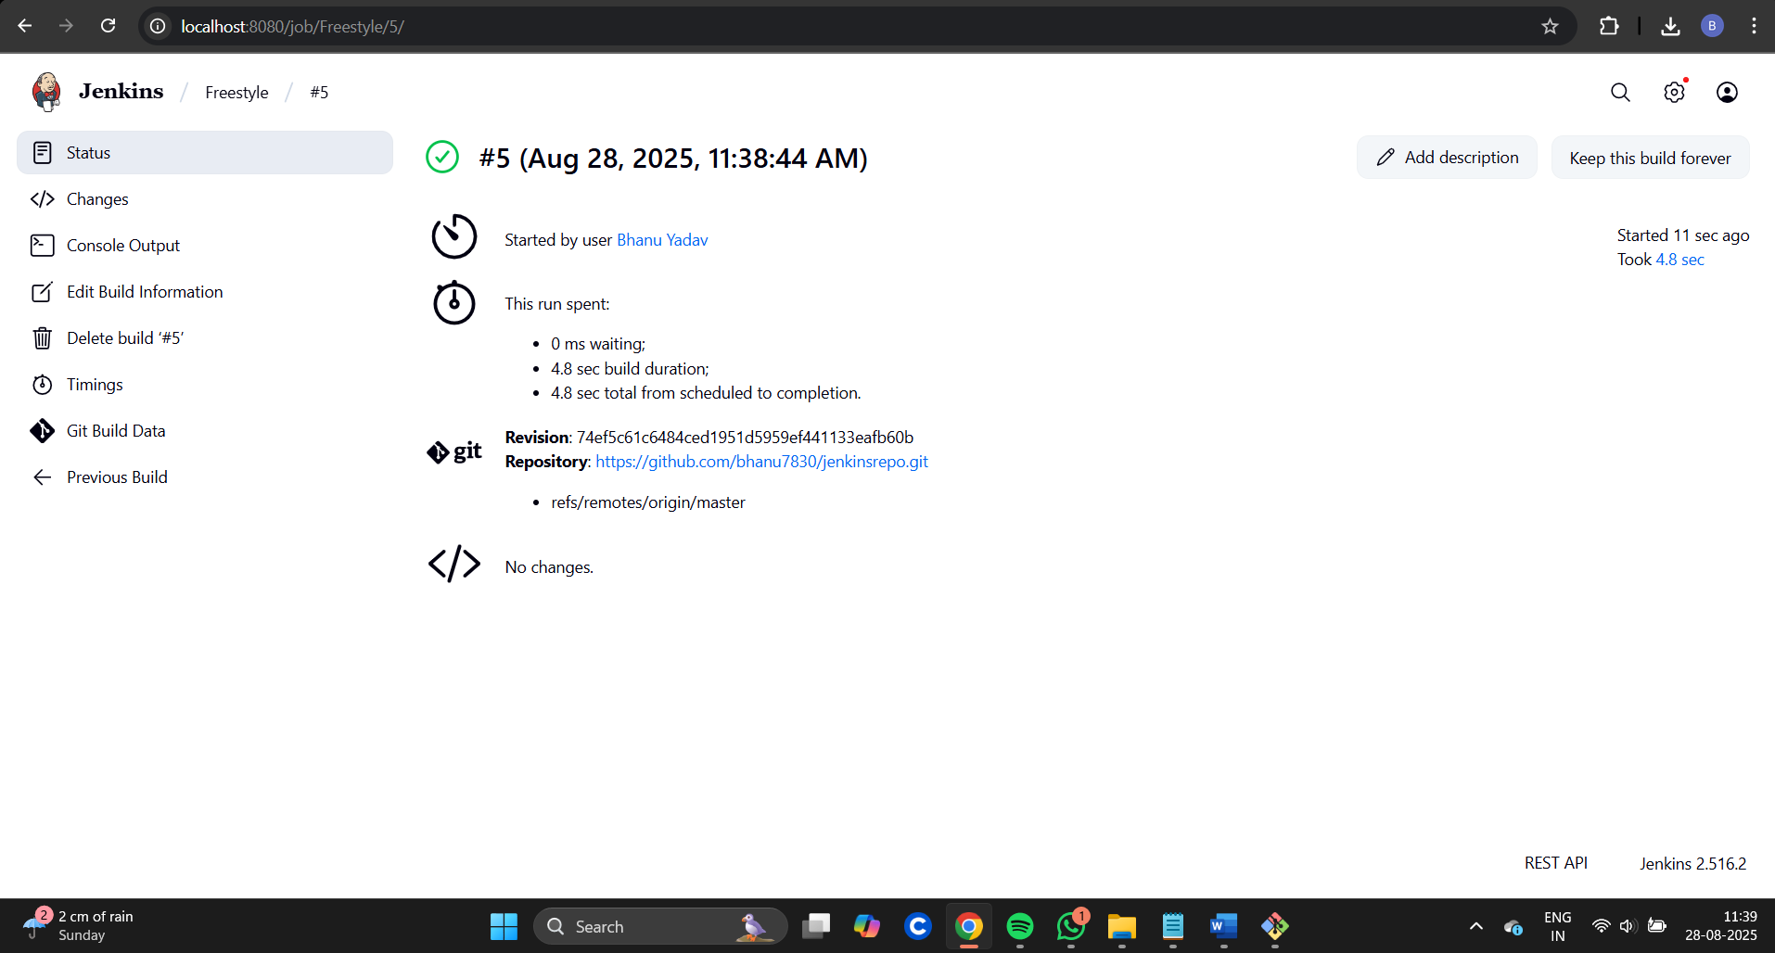

1. To schedule the build, click the required link under **Permalinks**
2. Click on **Console Output** to check out the process during the build process

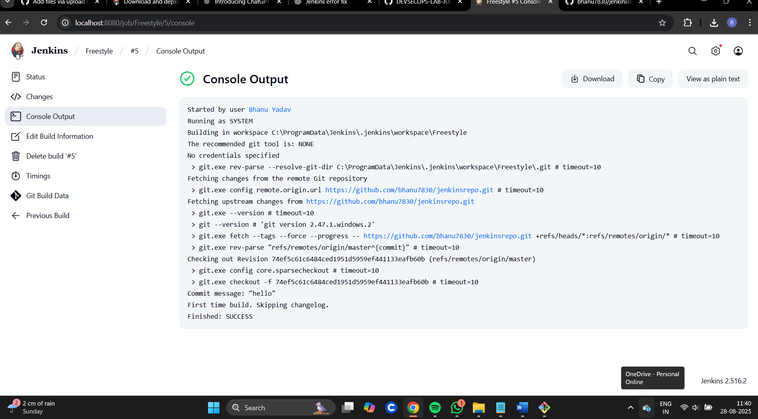

By following these steps, you have successfully set up a Jenkins job to automatically check out source code from a Git repository, enabling seamless integration and automation in your CI/CD pipeline.